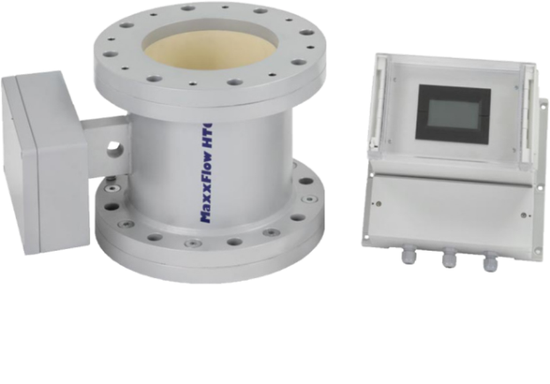

Calibrating your MaxxFlow HTC
Menu #
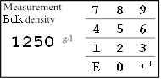
1.5 Density
Set bulk density in g/l. (Possible range 1 to 3000 g/l).
Enter the value.
g/l
708
E Exits without change
 Changes the value and returns to the previous menu.

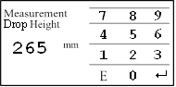
1.7 Drop Height
Enter drop height. This sets fixed-velocity automatically.
Enter the value.
mm
E Exits without change
200
 Changes the value and returns to the previous menu.

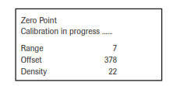
2.1.1 Zero Point Calibration
Start zero adjustment (empty pipe and conveying
turned on with no material).
Push ok to start zero calibration.
Cancel with no.

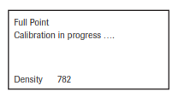
2.1.3 Full Calibration

Full Calibration with MaxxFlow HTC 100% filled in
no-flow condition.
Push ok to start zero calibration.
Cancel with no.
lbs
1. Now run the product for a material weigh test.
2. Calculate the over/under %.
(Actual – Displayed)/ Actual x 100 = % error
Now, add or subtract this error to 1 to get your Initial K Factor.
Example: Actual weight 5250lbs = 100% correct (truck scale verified)
Displayed weight after run is 4580lbs. (5250 – 4580)/5250 x 100 = 0.127 or +12.7% under
K Factor (I) = 1 + (+0.127) = 1.13
Now adjust the MaxxFlow to compensate the difference by using the K Factor.
(If you are 12.7% low then you need a 1.13 calibration factor to make the system add 13% to the weight).

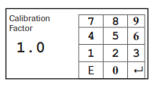
2.2 Factor
Correction factor affects directly the density measurement.
0.01 to 9.99

1.13
Default 1.0
Enter the value.
E Exits without change
 Changes the value and returns to the previous menu.

1. Now run the product for a 2nd material weigh test.
2. Calculate the over/under %.
Example: Actual weight before test 5250lbs = 100% correct weight
Displayed weight after run is 5110lbs. = (5250 – 5110)/5250 x 100 = +2.67% under
New K Factor = Old K Factor + % error = 1.13 + 2.67% = 1.16
Continue doing material weight tests until the K Factor is optimized.

Note: The first calibration sets the K factor. The 2nd, 3rd, etc. calibrations compensate the original K factor.

2.2 Factor
Correction factor affects directly the density measurement.
0.01 to 9.99

1.16
Default 1.0
Enter the value.
E Exits without change
 Changes the value and returns to the previous menu.

1. Now run the product for a 3rd material weigh test.
2. Calculate the over/under %.
Example: Actual weight before test 5250lbs = 100% correct weight
Displayed weight after run is 5288lbs. = (5250 – 5288)/5250 x 100 = -0.72% over
New K Factor = Old K Factor + % error = 1.16 + (-0.72%) = 1.15
Now adjust the Maxx Flow to compensate the difference.

2.2 Factor
Correction factor affects directly the density measurement.
0.01 to 9.99

1.15
Default 1.0
Enter the value.
E Exits without change
 Changes the value and returns to the previous menu.

Congratulations you have now calibrated your MaxxFlow HTC to your specific product.

If you need to calibrate the MaxxFlow HTC to a new product B, follow these procedures:
1. Understand that you DO NOT perform a Zero or Full Calibration! Instead, you need to find the multiplier to apply so as to realize the correct Product B totalized weight.
2. Reset the MFE100 totalizer and run a material weight test on the new product at least 3 times.
2. Calculate the average % error to realize the Product B Multiplier.
RUN Product B Actual Displayed Weight on MFE100
1 6570 5012
2 6540 5038
3 6595 5003
Avg 6568.33 5017.67

(Actual – Displayed)/ Displayed x 100 = % error, (6568.33 – 5017.67)/ 5017.67 x 100 = 30.90%
Corrected Product B Weight = Displayed Weight + 30.90%

Calibration Worksheet
(Please fill in the blanks)

1.5 Density _______________g/l

1.7 Drop Height _______________mm

2.1.1 Zero Point _______________Range

_______________OFFSET

_______________Density

2.1.3 Full Calibration _______________Density

Material Test (Product A)

Test1 _____________Actual ____________Displayed

Calculate: (Actual – Displayed)/ Actual = error (error x 100 = error %)
Initial K Factor = 1 + error = _______________ K Factor (I)

Test2 _____________Actual ____________Displayed _____________error % (2)
K Factor (2) = K Factor (I) + error % (2)

Test3 ____________Actual ____________Displayed _____________ error % (3)
K Factor (3) = K Factor (2) + error % (3)

Final K Factor (known as Calibration or Correction Factor)______________

Additional Product Material Tests (if more than 1 product)

Product B- Test1 _____________Actual ____________Displayed
Product B- Test2 _____________Actual ____________Displayed
Product B- Test3 _____________Actual ____________Displayed

Product B- Average _____________Actual ____________Displayed

(Average Actual – Average Displayed)/ Average Displayed x 100 = _________% error

Corrected Product B Weight = Displayed Weight + % error = __________________

Additional Product Material Tests (if more than 2 products)

Product C- Test1 _____________Actual ____________Displayed
Product C- Test2 _____________Actual ____________Displayed
Product C- Test3 _____________Actual ____________Displayed

Product C- Average _____________Actual ____________Displayed

(Average Actual – Average Displayed)/ Average Displayed x 100 = _________% error

Corrected Product C Weight = Displayed Weight + % error = __________________

Additional Product Material Tests (if more than 3 products)

Product D- Test1 _____________Actual ____________Displayed
Product D- Test2 _____________Actual ____________Displayed
Product D- Test3 _____________Actual ____________Displayed

Product D- Average _____________Actual ____________Displayed

(Average Actual – Average Displayed)/ Average Displayed x 100 = _________% error

Corrected Product D Weight = Displayed Weight + % error = __________________

Additional Product Material Tests (if more than 4 products)

Product E- Test1 _____________Actual ____________Displayed
Product E- Test2 _____________Actual ____________Displayed
Product E- Test3 _____________Actual ____________Displayed

Product E- Average _____________Actual ____________Displayed

(Average Actual – Average Displayed)/ Average Displayed x 100 = _________% error

Corrected Product E Weight = Displayed Weight + % error = __________________

GTS, Inc.
PO Box 799, Shalimar, FL 32579 USA
Phone: 850-651-3388 Fax: 850-651-4777
Email: info@onthelevel.com - Website: www.onthelevel.com

